**Beta Business**

**Requirements Specification**

**April 17, 2017**

Albi Trashani   
Igli Tola  
Ernaldo Gjomakaj  
Arnold Valteri  
OrnelaTorra

# Executive Summary

***1.1 Project Description***

It is a software that helps company to manage their finances, costumers and whole business. It will offer easy data exchange between different departments of the company.

The purpose of this project is to make a program which will help managers use their company data in a more efficient and effective way.

# Product/Service Description

## Product Context

This product is related to other financial softwares, because it helps in managing the finances of the whole business. It is independent, it doesn’t need to interface with a variety of related systems as all of the components will be genuine.

## User Characteristics

This product is designed to be used by many people who work in the company, and this program will require users to have knowledge on using this application and a two week course will be made in order to learn how to use this program. Employees with no knowledge will be strictly prohibited to use it.

So who is going to use this program?   
Let’s start with the higher hierarchy: The top managers: CEO, CFO will have a unique access to the program, different from the others since they need to know absolutely everything going on in their company (stuff like total revenues, cash flows, reports, transactions, debts etc.).  
Besides them, the employees, or let’s call them sales agents will also have access to the program, but unlike managers, sales agents will have limited access. It is not their responsibility, and definitely not their business to know every detail in the company they work for. So for now they will only have access to daily transactions, reports, bills, and also partially at the debts page.

## Constraints

For the product to work perfectly well, it needs to be installed at the proper machines. It will run smoothly on a high-spec PC, and okay in a medium PC, but it definitely will crash if you install it on an old, low-spec PC. Having all those databases and data will need a lot of free space in your PC.

# Requirements

## Functional Requirements

| Req# | Requirement | Comments | Priority | Date Rvwd | SME Reviewed / Approved |
| --- | --- | --- | --- | --- | --- |
| BR_01 | The program should include every product that the company has in inventory. | Business Process = “Adding products” | 1 | 03/04/17 | Albi T, ErnaldoGj,  Arnold V,  Igli T,  Ornela T |
| BR_02 | The program should calculate how much is left, cost of each product, how much will they sell it. | Business Process = “Calculations”  A missing product alert will help in informing our suppliers | 2 | 03/04/17 | Albi T, ErnaldoGj,  Arnold V,  Igli T,  Ornela T |
| BR_06 | The program should keep a record of all of the clients of the company. | Business Process = “Adding clients” | 2 | 03/04/17 | Albi T, ErnaldoGj,  Arnold V,  Igli T,  Ornela T |
| BR_09 | The program should be able to specify the clients, to add them in the debts page if they have any debts in the company. | Business Process=”Add client debts”  When clients pay their debts, they will no longer be in the debts page, and their status will be “No debts” | 2 | 03/04/17 | Albi T, ErnaldoGj,  Arnold V,  Igli T,  Ornela T |
| BR_13 | The program should be able to see reports from daily sales of the company. | Business Process=” Reports”  A calendar will be visible to make it easier for users to navigate through the days/months to see their balances and numbers | 2 | 03/04/17 | Albi T, ErnaldoGj,  Arnold V,  Igli T,  Ornela T |
| BR_14 | The program should be able to identify users | Business Process=”Credentials”  A sales agent doesn’t have same access as managers so the login page will identify users. | 1 | 03/04/17 | Albi T, ErnaldoGj,  Arnold V,  Igli T,  Ornela T |

## User Interface Requirements

There will be a menu in the main page of the program, with the buttons showing different modules of the program, to make it easier for the users (admins and employees).

It will be user friendly and intuitive. If the user makes a mistake while using the program, error alerts will appear with specific messages shown what you have done wrong while operating in it. The modules will be shown in 2 columns and 3 rows, making it a simple and users will have it easier to find their modules.

## Usability

Accessibility – The top managers: CEO, CFO will have a unique access to the program, different from the others since they need to know absolutely everything going on in their company (stuff like total revenues, cash flows, reports, transactions, debts etc.).  
Besides them, the employees, or let’s call them sales agents will also have access to the program, but unlike managers, sales agents will have limited access.

Learnability – The system will be easy to use, everything will be explained inside the program on mouse hover. Although users have to learn this program 2 weeks before they start using it.

## Performance

We will make sure our program performs at its highest speed. When the user tries to find a product from our database, the program searches it by name and it will be able to find it in 1-2 seconds, depending on the search key the user has provided. When looking at transactions made during the day, the program will firstly show the most recent ones, then if the user wants to see more, he will have a button to show all of the transactions made during that day (or other days).

### Capacity

The program will be flexible for all types of businesses, which means that no matter how big the business is, the program will still be able to process all the data in no big deal, it will have a big capacity. Users will be able to get as many reports as they want, anytime they want them.

### Availability

Hours of operation: The program will be required to be online by users at least 8 hours ( since the average working hours per day for a worker is 8 hours).

Level of availability: The program will be available 24/7 for the users.

By the geographic means, the program will be available from everywhere, the only constraint may be the slow internet connection that users may face from where they are using the program.

### Latency

The response time for the program to process some data will be very efficient and very fast, not including conditions where users have installed this program on old and slow PC’s.

## Manageability/Maintainability

### Monitoring

The program as we have previously mentioned will be user friendly, and very easy to use. Users will have no issues in using our program, since everything will be explained on mouse hover on everything they see on the program. Also a “?” button will be available on top corner of the program’s window so the user can check for solutions in case they have some problems with the program. If the information that they find instructed on the program is not enough for them, and they are facing problems that they cannot solve, we will provide users with some contact details from the programmers of the Beta Business which will assist its clients in the best and fastest way possible.

### Maintenance

The simple and efficient design of Beta Business will help users do their job without programming skills. It is easily understandable. Later on updates will be available to download for the program.

### Operations

Users can store new products when the program doesn’t have that information.

The user can access the system whenever they need information.

The user can add, delete clients.

The user can add, delete, update debts.

The user can store new transactions.

The user can see daily, weekly, monthly, yearly reports.

The user can search for specific person.

The user can search for specific transaction.

The user can search for specific debt.

The user can check financial situations for specific periods.

## System Interface/Integration

Beta Business is a software that serves as a connecting interface between users and a database, which will contain everything it needs in order to run a business. The program can be accessible from every computer that has Beta Business installed, with the only condition not to be very low spec PC, for a maximal performance and efficiency.

## Domain Requirements.

Domain requirements reflect the environment in which the system operates so, when we talk about our program domain we mean environments such as transactions, reports etc.

The domain requirements are fundamental for our project because a lot of calculations shall be done.  If these requirements are not satisfied, it may be impossible to make the system work satisfactorily. There will be multiple multiplications such as:

Total products price= price x quantity.

Also there will be a lot of additions such as : sum of different products.

# 

# User Scenarios/Use Cases

|  |  |  |
| --- | --- | --- |
| **Nr.** | **User Story Name** | **Description** |
| 1. | Log in | Provides the users to log in, by using their user name and password, in order to access the program. Employee's login is different from Admin's login. |
| 2. | Add Products | Both types of users have access to this part of the program, and they have to add new products. |
| 3. | Add Clients | Both types of users have access to this part of the program, and they have to add new clients. |
| 4. | Add Debts | Both types of users have access to this part of the program, and they have to add new debts. |
| 5. | Delete Debts | Both types of users have access to this part of the program, and they have to delete debts. |
| 6. | Reports | This module is accessed only by the Admin. They can have a detailed information about business activity. |
| 7. | Search name | The user search for a person that he want to his activity in company by typing his name. After the name is typed there it will be shown all information for this person. |
| 8. | Search date | The user can search for all transactions made in company during a period of time by entering beginning and ending date. |
| 9. | Log out | Provides the user to end his ccessibility in the program. |

**Use case name:** Log in

**Overview:**Provides the users to log in, by using their user name and password, in order to access the program. Employee's login is different from Admin's login.

**Actor(s):** Users(Admin), Users(Employee)

**Precondition(s):** Valid username and password.

**Scenario flow**

**Main (success) flow :**

1. Beta Business displays the log in to the users

2. User enters the username and password.

3. Beta Business checks the User’s username and password.

4. Beta Business displays the home page.

**Alternate Flows-**

1: Wrong username or password.

Beta Business displays an error message. The system displays the log in form again.

**Post condition(s)** User is logged in. They have access according to their position in the company.

**Use case name:** Add Products

**Overview**: Both types of users have access to this part of the program, and they have to add new products.

**Actor(s):** Users(Admin), Users(Employee)

**Precondition(s):** User must be logged in.

**Scenario flow**

**Main (success) flow :**

1. User logs in to Beta Business.

2. User goes to Inventory, and goes to add new tab.

3. User enters the new product's info

4. User clicks add new product.

**Alternate Flows-**

1: No valid data were put inside the boxes.

2. Some of the boxes were left blank

Beta Business displays an error message. The system displays the form to complete it again.

**Post condition(s)** Data is updated. Now user can access other functionalities.

**Use case name:** Add Clients

**Overview**: Both types of users have access to this part of the program, and they have to add new clients.

**Actor(s):** Users(Admin), Users(Employee)

**Precondition(s):** User must be logged in.

**Scenario flow**

**Main (success) flow** :

1. User logs in to Beta Business.

2. User goes to Clients, and goes to add new tab.

3. User enters the new Client's info

4. User clicks add new client.

**Alternate Flows-**

1: No valid data were put inside the boxes.

2. Some of the boxes were left blank

Beta Business displays an error message. The system displays the form to complete it again.

Post condition(s) Data is updated. Now user can access other functionalities.

**Use case name:**Add Debts

**Overview**: Both types of users have access to this part of the program, and they have to add new debts.

**Actor(s):** Users(Admin), Users(Employee)

**Precondition(s):** User must be logged in.

**Scenario flow**

**Main (success) flow :**

1. User logs in to Beta Business.

2. User goes to Debts, and goes to add new debt tab.

3. User enters the new Debt's info

4. User clicks add new debt.

**Alternate Flows-**

1: No valid data were put inside the boxes.

2. Some of the boxes were left blank

Beta Business displays an error message. The system displays the form to complete it again.

**Post condition(s)** Data is updated. Now user can access other functionalities.

**Use case name**: Delete Debts.

**Overview**: Both types of users have access to this part of the program, and they have to delete debts.

**Actor(s):** Users(Admin), Users(Employee)

**Precondition**(s): User must be logged in.

**Scenario flow**

**Main (success) flow** :

1. User logs in to Beta Business.

2. User goes to Clients.

3. User searches for the Client's info.

4. User check's if the client is a debitor in the company.

5. User deletes the debt he has if he has paid the required amount.

**Alternate Flows-**

1.No debts are in the company.

2. Client hasn't paid the required amount

Beta Business displays an error message.

Post condition(s) Data is updated. Now user can access other functionalities.

**Use case name**:Reports

**Overview**: This module is accessed only by the Admin. They can have a detailed information about business activity.

**Actor(s):** Users(Admin),

**Precondition(s):** User must be logged in.

**Scenario flow**

**Main (success) flow :**

1. User logs in to Beta Business.

2. User goes to Reports.

3.User chooses the the date he want to check.

**Alternate Flows-**

1: No valid data were put inside the boxes.

2. Some of the boxes were left blank.

3.This date isn't registered yet.

Beta Business displays an error message. The system displays the form to complete it again.

**Post condition(s)** Data is updated. There wil be shown the requested raports.

# 

# 

# Requirements Confirmation/Stakeholder sign-off

|  |  |  |
| --- | --- | --- |
| Meeting Date | Attendees (name and role) | Comments |
| 04/13/17 | Albi Trashani, Igli Tola,  Arnold Valteri,  ErnaldoGjomakaj,  OrnelaTorra | Confirmed 6 modules for the  software. |
| 04/14/17 | Albi Trashani, Igli Tola,  Arnold Valteri,  ErnaldoGjomakaj,  OrnelaTorra | Approved products that will be registered in the software database. |
| 04/15/17 | Albi Trashani, Igli Tola,  Arnold Valteri,  ErnaldoGjomakaj,  OrnelaTorra | New feature confirmed. The program will calculate the cost of each product and also the net profit. |
| 04/16/17 | Albi Trashani, Igli Tola,  Arnold Valteri,  ErnaldoGjomakaj,  OrnelaTorra | Added client section. This section will keep record for all the clients registered in the company. |
| 04/17/17 | Albi Trashani, Igli Tola,  Arnold Valteri,  ErnaldoGjomakaj,  OrnelaTorra | Confirmed sales report module. This section will show all sales and transaction made in the company. |
| 04/18/17 | Albi Trashani, Igli Tola,  Arnold Valteri,  ErnaldoGjomakaj,  OrnelaTorra | Confirmed user recognition. The program will recognize which user has logged in and will provide the provided access for that user. |

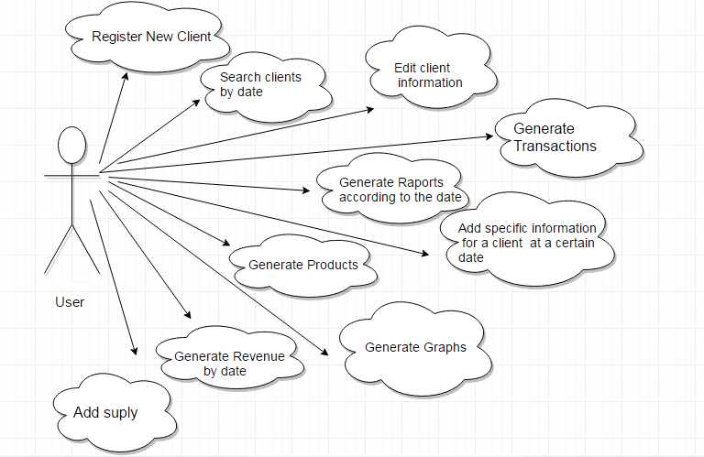

**Admin Use Case**

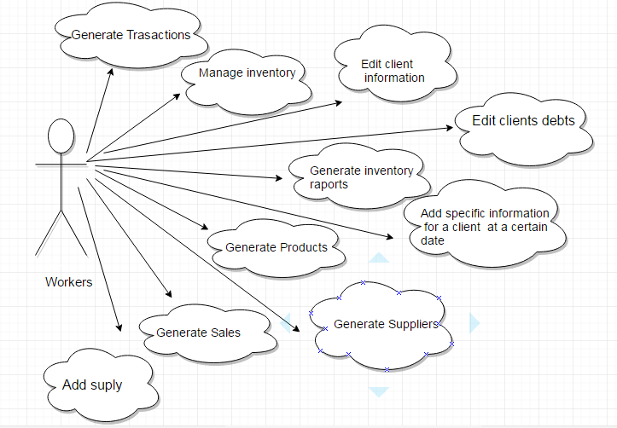

**Employee Use Case Diagram**

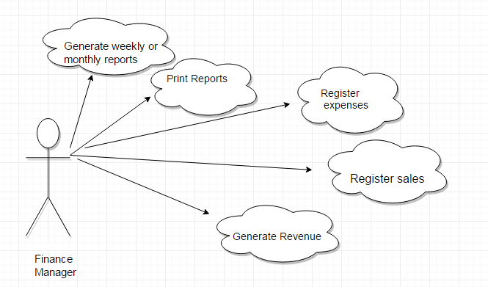

**Finance Manager Use Case Diagram**

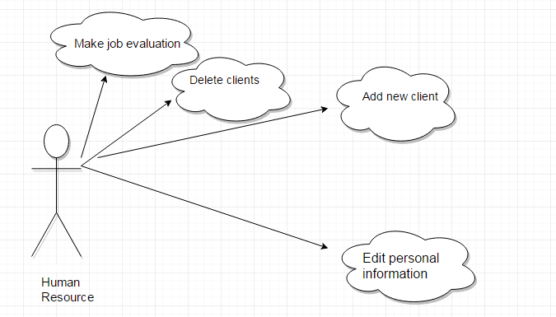

**User Use Case Diagram**

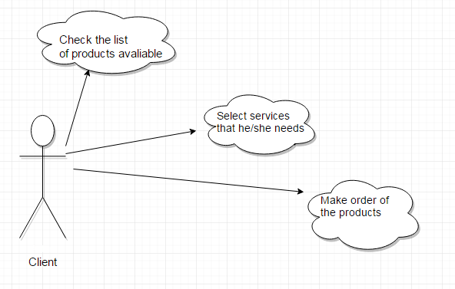

**Client Use Case Diagram**